MARVEL TRAILERS – Mobile App

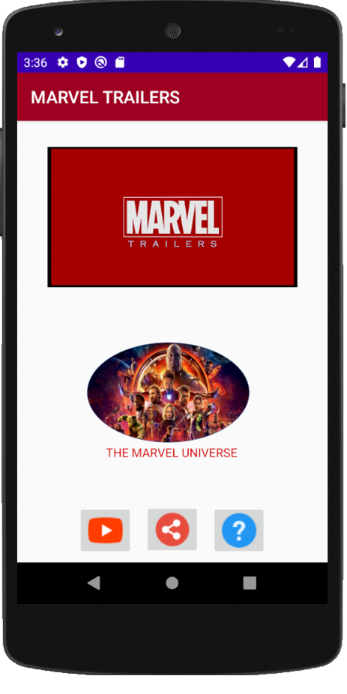 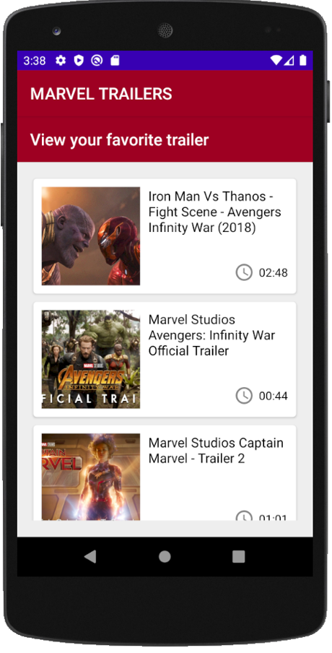

1. This is the home screen, and the video list screen.
2. This list is a recycler view list, showing thumbnails of the favorite marvel movie trailers and videos from MCU.

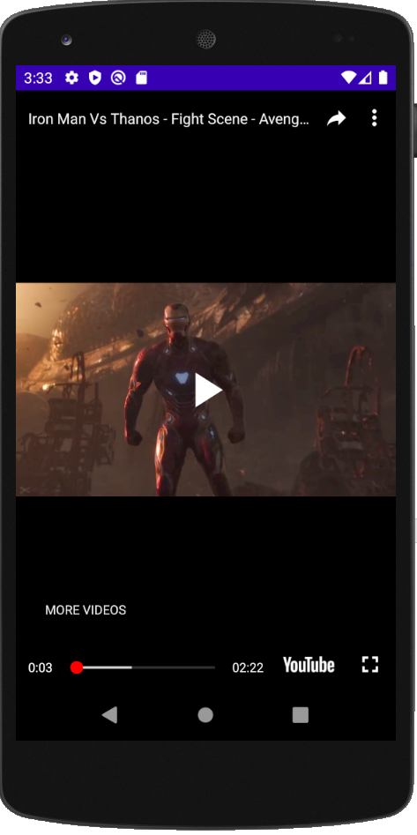 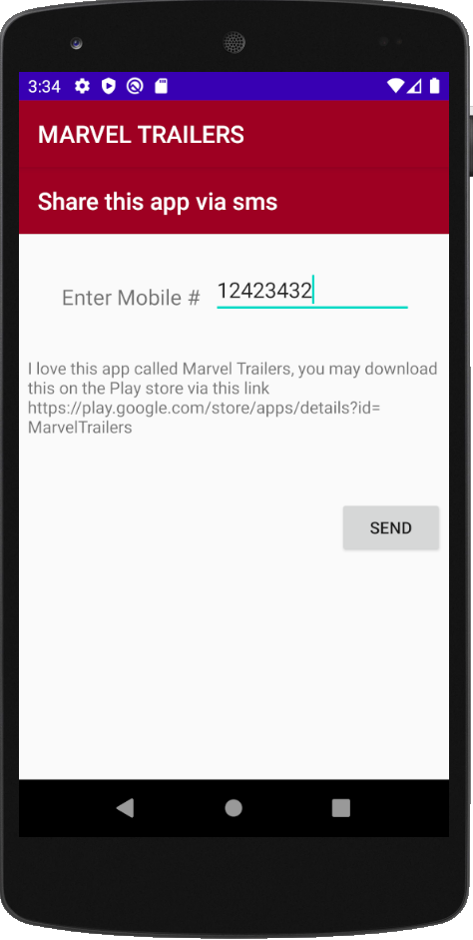

1. This screen displays, video is played on clicking any thumbnail image from the list of video screen.
2. Displays the screen to send/share this app link with your contacts.

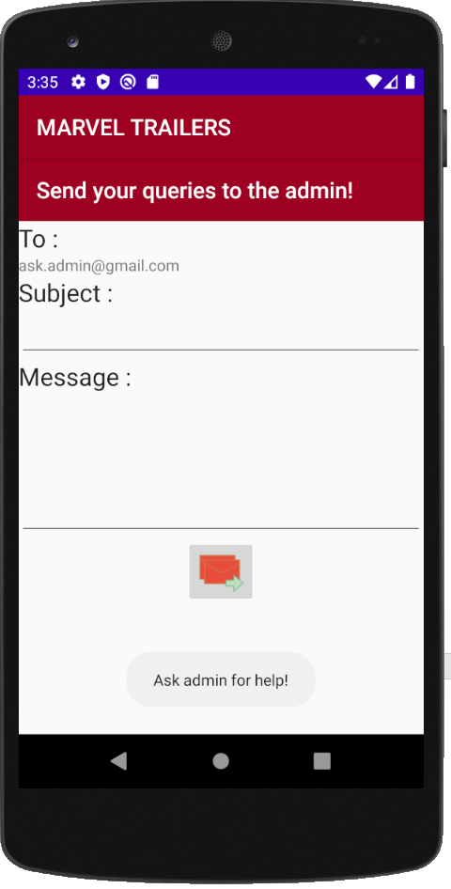

1. This screen shows, you can contact admin for help or any queries.